A LEGACY IN PRINT
Newspaper Clippings Archive - Recompiled Edition
Pastor Johnny Kemp, the Kemp Family,
Missionary Evangelist Center, Ministry, Athletics,
Community Leadership & Public Service
Historical newspaper clippings preserved with original images,
transcriptions, dates, and contextual notes.

About This Archival Edition
This recompiled edition brings together all newspaper clippings supplied for the archive to date. The collection documents athletics, ministry, family history, community service, and public leadership connected to Johnny Kemp and the Kemp family.
Each entry includes the original newspaper image and a readable transcription. Confirmed dates and years are stated exactly when available. When a year is not visible or was not supplied, the entry is marked as undated rather than assigning an unverified date.
The transcriptions preserve the historical wording and names as closely as possible while converting newspaper column breaks into normal paragraphs for readability.
Contents
Part I: Athletics & Early Years
1. Sam Payne Paces Miami Dade To State Title - May 3, 1968
2. Golden Bulls Run in Bob Hayes Meet - Undated
Part II: Ministry & Community
3. Missionary Evangelist Center - Third Annual Gospel Concert - 1987
4. Deacon Willie L. Kemp Obituary - 1989
5. Lloyd Singers Host Banquet - 1990
6. Deliverance Center Celebration - 1994
7. Believers Life Ministries Host Prayer Breakfast - Undated
8. Special Service at Brown's Chapel - Undated
9. Appreciation for Pastor N. Kelly - Undated
10. Pre-Halloween Tea - Undated
11. Pastor's Appreciation at Allen Chapel A.M.E. Church - Undated
Part III: Family & Community Legacy
12. Murial McKenzie and Zabriena Daniels Wedding - Undated
13. Maurice L. Kemp Swearing-In Ceremony - Undated

PART I
Athletics & Early Years

1. Sam Payne Paces Miami Dade To State Title
The Miami Times - Friday, May 3, 1968 - Page 37
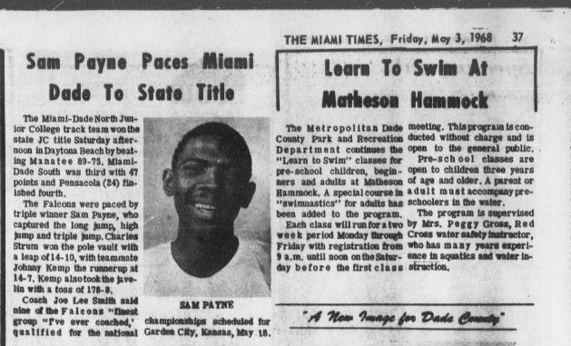
Transcription
The Miami-Dade North Junior College track team won the state JC title Saturday afternoon in Daytona Beach by beating Manatee 89-75. Miami-Dade South was third with 47 points and Pensacola (24) finished fourth.
The Falcons were paced by triple winner Sam Payne, who captured the long jump, high jump and triple jump. Charles Strum won the pole vault with a leap of 14-10, with teammate Johnny Kemp the runner up at 14-7. Kemp also took the javelin with a toss of 178-8.
Coach Joe Lee Smith said nine of the Falcons' finest group "I've ever coached," championships scheduled for qualified for the national Garden City, Kansas, May 18.
Archival note: This clipping documents Johnny Kemp as a Miami-Dade North Junior College athlete, runner-up in the pole vault at 14 feet 7 inches and winner of the javelin with a throw of 178 feet 8 inches.

2. Golden Bulls Run in Bob Hayes Meet
Undated - Event listed for Friday, April 8
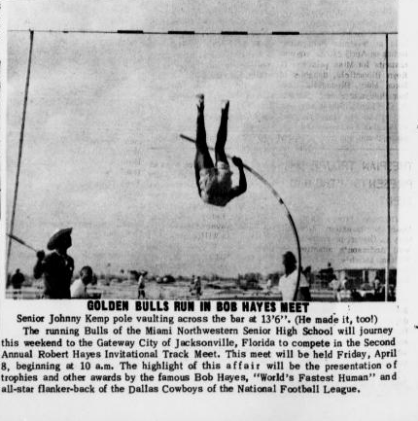
Transcription
Senior Johnny Kemp pole vaulting across the bar at 13'6". (He made it, too!)
The running Bulls of the Miami Northwestern Senior High School will journey this weekend to the Gateway City of Jacksonville, Florida to compete in the Second Annual Robert Hayes Invitational Track Meet. This meet will be held Friday, April 8, beginning at 10 a.m. The highlight of this affair will be the presentation of trophies and other awards by the famous Bob Hayes, "World's Fastest Human" and all-star flanker-back of the Dallas Cowboys of the National Football League.

PART II
Ministry & Community

3. Missionary Evangelist Center - Third Annual Gospel Concert
Saturday, April 25, 1987 - 8:00 p.m.
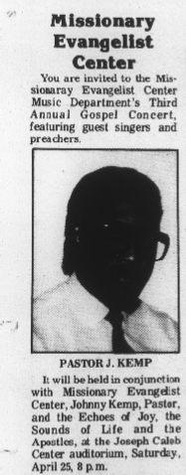
Transcription
You are invited to the Missionary Evangelist Center Music Department's Third Annual Gospel Concert, featuring guest singers and preachers.
PASTOR J. KEMP
It will be held in conjunction with Missionary Evangelist Center, Johnny Kemp, Pastor, and the Echoes of Joy, the Sounds of Life and the Apostles, at the Joseph Caleb Center auditorium, Saturday, April 25, 8 p.m.

4. Deacon Willie L. Kemp Obituary
1989 - Died December 6
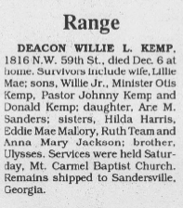
Transcription
DEACON WILLIE L. KEMP, 1816 N.W. 59th St., died Dec. 6 at home. Survivors include wife, Lillie Mae; sons, Willie Jr., Minister Otis Kemp, Pastor Johnny Kemp and Donald Kemp; daughter, Arie M. Sanders; sisters, Hilda Harris, Eddie Mae Mallory, Ruth Team and Anna Mary Jackson; brother, Ulysses.
Services were held Saturday, Mt. Carmel Baptist Church. Remains shipped to Sandersville, Georgia.

5. Lloyd Singers Host Banquet
March 16, 1990 - 7:30 p.m.
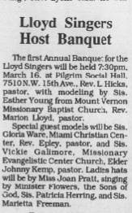
Transcription
The first Annual Banquet for the Lloyd Singers will be held 7:30 p.m., March 16, at Pilgrim Social Hall, 7510 N.W. 15th Ave., Rev. L. Hicks, pastor, with modeling by Sis. Esther Young from Mount Vernon Missionary Baptist Church, Rev. Marlon Lloyd, pastor.
Special guest models will be Sis. Gloria Ware, Miami Christian Center, Rev. Epley, pastor, and Sis. Vickie Gallimore, Missionary Evangelistic Center Church, Elder Johnny Kemp, pastor.
Ladies hats will be by Miss Joan Pratt, singing by Minister Flowers, the Sons of God, Sis. Patricia Herring, and Sis. Marietta Freeman.

6. Deliverance Center Celebration
May 18-27, 1994 - Nightly at 7:30 p.m.
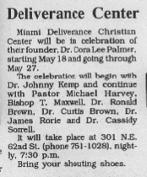
Transcription
Miami Deliverance Christian Center will be in celebration of their founder, Dr. Cora Lee Palmer, starting May 18 and going through May 27.
The celebration will begin with Dr. Johnny Kemp and continue with Pastor Michael Harvey, Bishop T. Maxwell, Dr. Ronald Brown, Dr. Curtis Brown, Dr. James Rorie, and Dr. Cassidy Sorrell.
It will take place at 301 N.E. 62nd St. (phone 751-1028), nightly, 7:30 p.m.
Bring your shouting shoes.

7. Believers Life Ministries Host Prayer Breakfast
Undated - Saturday, June 30 - 9:30 a.m.
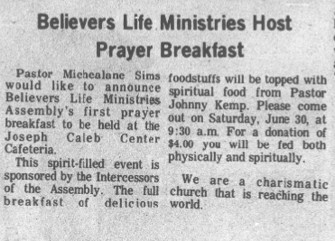
Transcription
Pastor Michealane Sims would like to announce Believers Life Ministries Assembly's first prayer breakfast to be held at the Joseph Caleb Center Cafeteria.
This spirit-filled event is sponsored by the Intercessors of the Assembly. The full breakfast of delicious foodstuffs will be topped with spiritual food from Pastor Johnny Kemp. Please come out on Saturday, June 30, at 9:30 a.m. For a donation of $4.00 you will be fed both physically and spiritually.
We are a charismatic church that is reaching the world.

8. Special Service at Brown's Chapel
Undated - Sunday - 4:00 p.m.
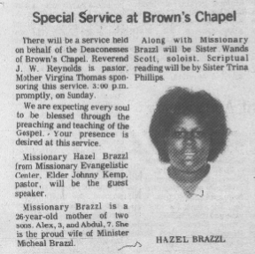
Transcription
There will be a service held on behalf of the Deaconesses of Brown's Chapel. Reverend J. W. Reynolds is pastor. Mother Virginia Thomas sponsoring this service. 4:00 p.m. promptly, on Sunday.
We are expecting every soul to be blessed through the preaching and teaching of the Gospel. Your presence is desired at this service.
Missionary Hazel Brazzl from Missionary Evangelistic Center, Elder Johnny Kemp, pastor, will be the guest speaker.
Missionary Brazzl is a 26-year-old mother of two sons, Alex, 3, and Abdul, 7. She is the proud wife of Minister Michael Brazzl.
Along with Missionary Brazzl will be Sister Wands Scott, soloist. Scriptural reading will be by Sister Trina Phillips.

9. Appreciation for Pastor N. Kelly
Undated - Friday, March 17 - 8:00 p.m.
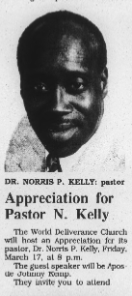
Transcription
DR. NORRIS P. KELLY: pastor
The World Deliverance Church will host an Appreciation for its pastor, Dr. Norris P. Kelly, Friday, March 17, at 8 p.m.
The guest speaker will be Apostle Johnny Kemp.
They invite you to attend.

10. Pre-Halloween Tea
Undated - October 29 - 4:00 p.m.
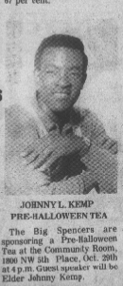
Transcription
JOHNNY L. KEMP
PRE-HALLOWEEN TEA
The Big Spenders are sponsoring a Pre-Halloween Tea at the Community Room, 1800 N.W. 5th Place, Oct. 29th at 4 p.m. Guest speaker will be Elder Johnny Kemp.

11. Pastor's Appreciation at Allen Chapel A.M.E. Church
Undated - September 11
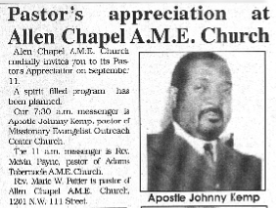
Transcription
Allen Chapel A.M.E. Church cordially invites you to its Pastor's Appreciation on September 11.
A spirit-filled program has been planned.
Our 7:30 a.m. messenger is Apostle Johnny Kemp, pastor of Missionary Evangelistic Outreach Center Church.
The 11 a.m. messenger is Rev. Melvin Davis, pastor of Adams Tabernacle A.M.E. Church.
Rev. Marie W. Porter is pastor of Allen Chapel A.M.E. Church, 1201 N.W. 111 Street.
Photo caption: Apostle Johnny Kemp.

PART III
Family & Community Legacy

12. Murial McKenzie and Zabriena Daniels Wedding
Undated - Saturday, October 11
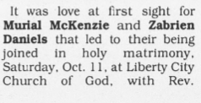 | 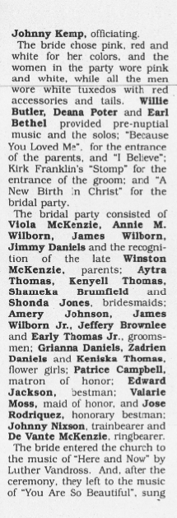 | 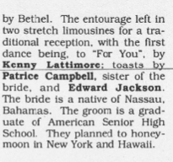
Transcription
It was love at first sight for Murial McKenzie and Zabriena Daniels that led to their being joined in holy matrimony, Saturday, Oct. 11, at Liberty City Church of God, with Rev. Johnny Kemp, officiating.
The bride chose pink, red and white for her colors, and the women in the party wore pink and white, while all the men wore white tuxedos with red accessories and tails. Willie Butler, Deana Poter and Earl Bethel provided pre-nuptial music and the solos; "Because You Loved Me", for the entrance of the parents; and "I Believe"; Kirk Franklin's "Stomp" for the entrance of the groom; and "A New Birth In Christ" for the bridal party.
The bridal party consisted of Viola McKenzie, Annie M. Wilborn, James Wilborn, Jimmy Daniels and the recognition of the late Winston McKenzie, parents; Aytra Thomas, Kenyell Thomas, Shameka Brummield and Shonda Jones, bridesmaids; Amery Johnson, James Wilborn Jr., Jeffery Brownlee and Early Thomas Jr., groomsmen; Ghrian Daniels, Zadrien Daniels and Keniska Thomas, flower girls; Patrice Campbell, matron of honor; Edward Jackson, bestman; Valarie Moss, maid of honor, and Jose Rodriquez, honorary bestman; Johnny Nixon, trainbearer and De Vante McKenzie, ringbearer.
The bride entered the church to the music of "Here and Now" by Luthur Vandross. And, after the ceremony, they left to the music of "You Are So Beautiful", sung by Bethel. The entourage left in two stretch limousines for a traditional reception, with the first dance being, to "For You", by Kenny Lattimore; toasts by Patrice Campbell, sister of the bride, and Edward Jackson. The bride is a native of Nassau, Bahamas. The groom is a graduate of American Senior High School. They planned to honeymoon in New York and Hawaii.
Archival note: The original clipping segment supplied does not display the article headline. The archive title is descriptive.

13. Maurice L. Kemp Swearing-In Ceremony
Undated - The Miami Times
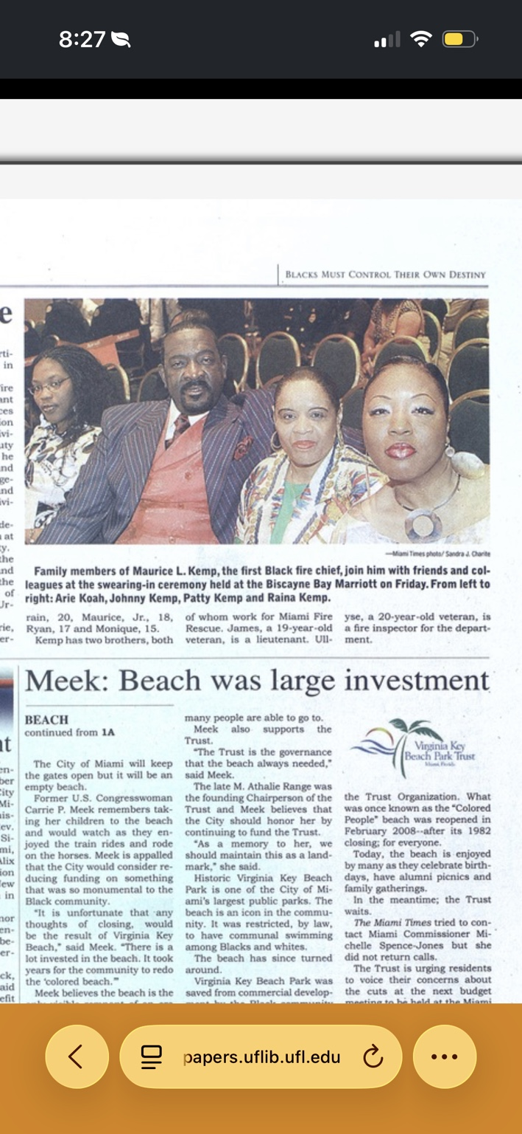
Transcription
Family members of Maurice L. Kemp, the first Black fire chief, join him with friends and colleagues at the swearing-in ceremony held at the Biscayne Bay Marriott on Friday. From left to right: Arie Koah, Johnny Kemp, Patty Kemp and Raina Kemp.
Photo credit: Miami Times photo / Sandra J. Charite.
Archival note: This clipping documents the Kemp family's presence at the swearing-in of Maurice L. Kemp as the first Black fire chief.

Historical Reference Index
Johnny Kemp: Athlete, pastor, elder, apostle, guest speaker, wedding officiant, and ministry leader documented across the collection.
Maurice L. Kemp: Identified in The Miami Times caption as the first Black fire chief.
Deacon Willie L. Kemp: 1989 family obituary listing Pastor Johnny Kemp among his sons.
Missionary Evangelist Center / Missionary Evangelistic Center: Church and ministry organization appearing in multiple gospel and community event clippings.
Missionary Evangelistic Outreach Center Church: Named in the Allen Chapel A.M.E. Church appreciation clipping with Apostle Johnny Kemp as pastor.
Miami-Dade North Junior College: Johnny Kemp competed in track and field, including pole vault and javelin, in the 1968 state championship report.
Miami Northwestern Senior High School: Johnny Kemp appears in the Bob Hayes Invitational clipping as a senior pole vaulter.
Joseph Caleb Center: Venue appearing in the prayer breakfast and gospel concert clippings.
End of the recompiled archive currently included in this volume.

